Database Document

The process of designing database includes these steps:

**UML Diagram**

First, we need to define what class we want to include in our database, which attributes of each class should have, which attributes are primary key [1] and the relationship between them.

[1] A primary key is a key that uniquely identifies each instance in a class. It serves as a means to differentiate one instance from another. The primary key can consist of a single attribute or a combination of multiple attributes.

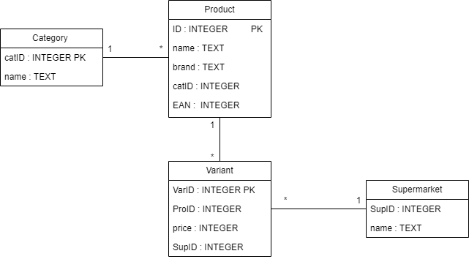

Image 1. UML diagram of database

**Functional Dependencies**

Products(ID,name,brand,catID,EAN)

Supermarkets(supID,name)

Variants(varID,proID,price,supID)

Categories(catID,name)

The Products table stores information about the products owned by the supermarkets, including the ID(identifier), name, brand, category ID, and EAN (European Article Number).

The Supermarkets table contains information about different supermarkets, including the supermarket ID and its name.

The Variants table stores details about different variants or versions of products available across supermarkets, including variant ID, product ID, its price and supermarket ID.

The Categories table allows for the organization and classification of products into different categories, including category ID and its name.